We created GitHub user in week four, and we finished the job on GitHub, summarized the first three weeks of the job on the wiki, and represented the network diagram as the Gant chart. Create a repository on GitHub.

The four members of our group have a clear division of labor when they complete their tasks. This time, the specific content is completed by the division of labor among the four people. A viable action is for the group members to actively advise and to actively complete their own part of the task when accepting the division of labour. In the process of completing a task, the unworkable action is to complete the task too long. What still needs to be improved in the future is to improve efficiency and enhance communication within the Group.

<https://github.com/Victoriaia1/Group19-2021.git>

<https://github.com/Victoriaia1/e-shopping.git>

Wiki:

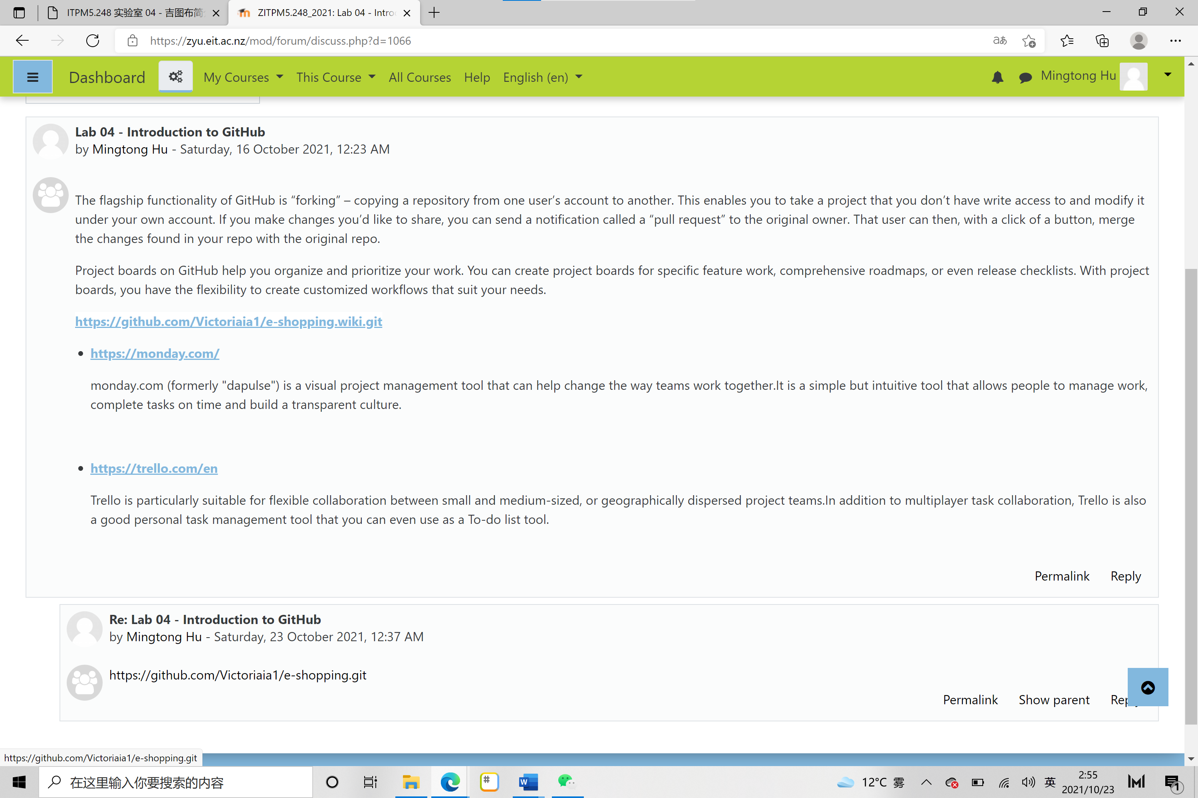

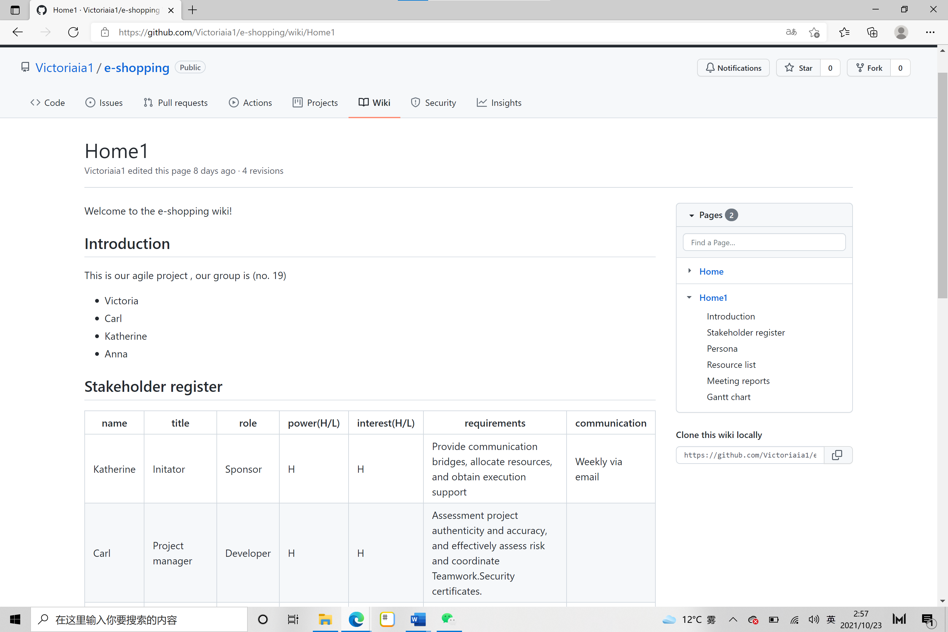

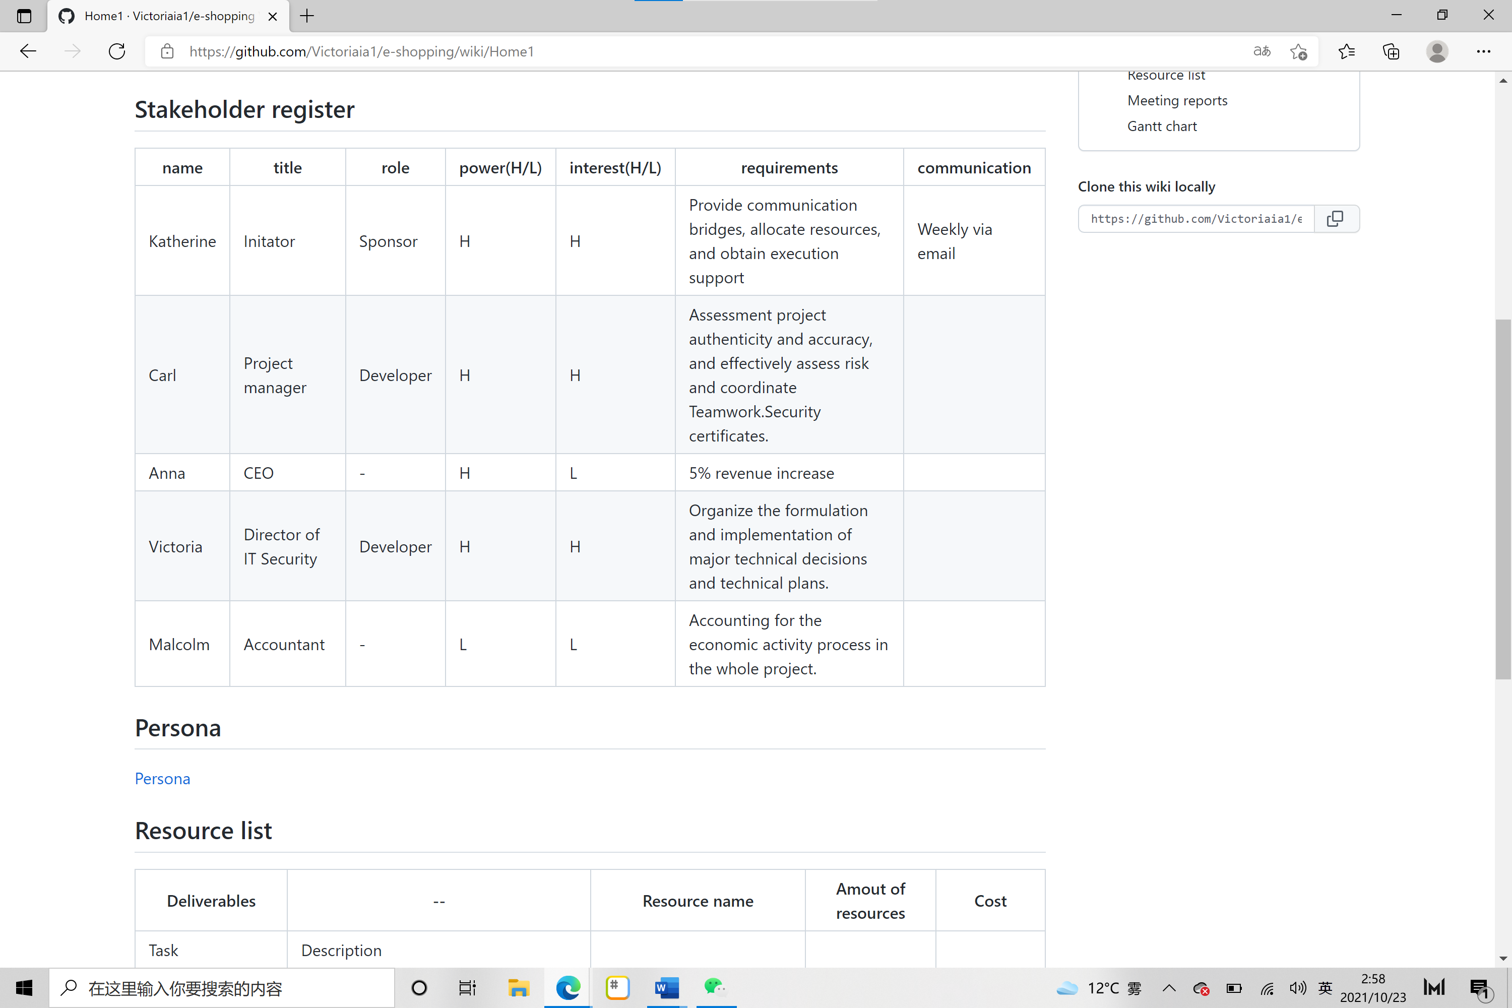

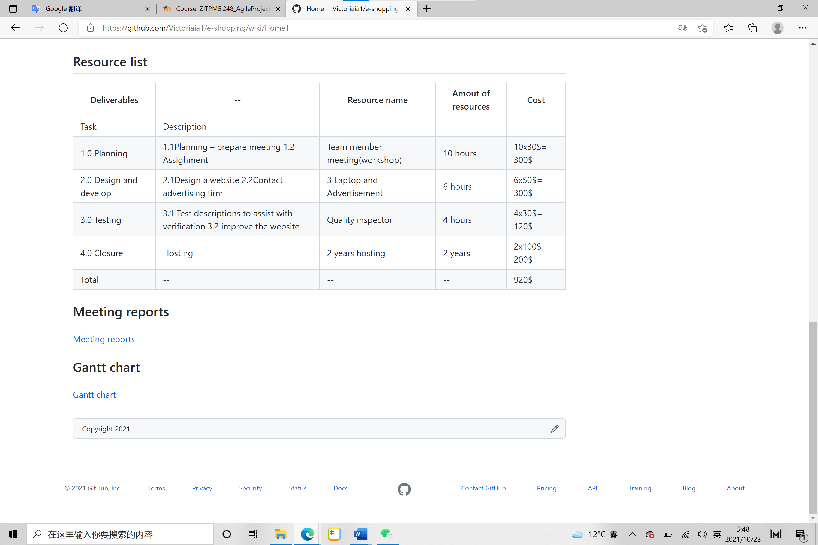

Grant chart:

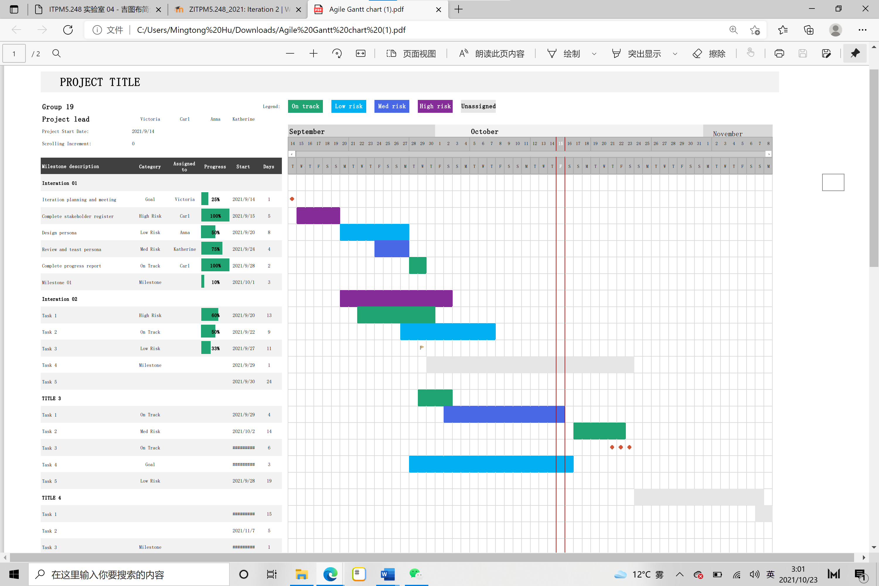

Group19-2021:

